Tasmanian Dam Case
The Tasmanian Dam Case is the most famous and influential environmental law case in Australian history. It was also a landmark in Australian constitutional law.
In it, the Commonwealth Government succeeded in stopping a large hydro-electric dam proposed to be constructed in South-West Tasmania. The seven judges of the High Court split 4:3 in deciding (amongst other matters) that the Commonwealth had power under section 51(xxix) of the Australian Constitution to stop the dam based on Australia’s international obligations under the World Heritage Convention.
The Tasmanian Dam Case is the most famous and influential environmental law case in Australian history. It was also a landmark in Australian constitutional law.
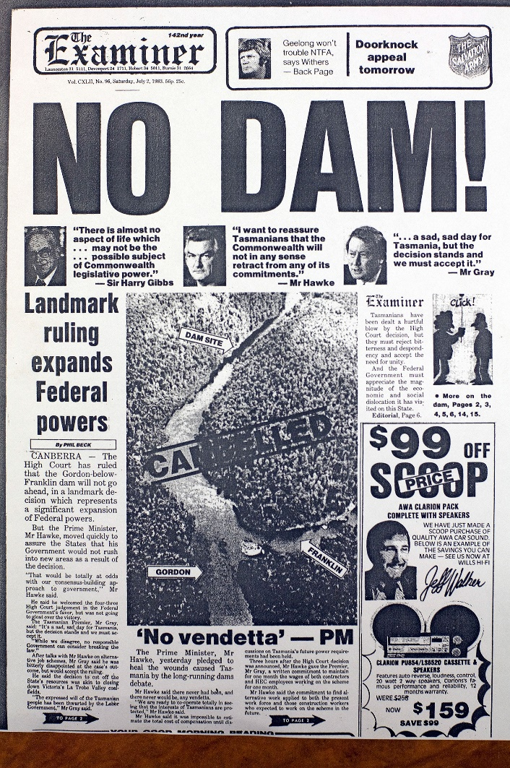
In it, the Commonwealth Government succeeded in stopping a large hydro-electric dam proposed to be constructed in South-West Tasmania. The seven judges of the High Court split 4:3 in deciding (amongst other matters) that the Commonwealth had power under section 51(xxix) of the Australian Constitution to stop the dam based on Australia’s international obligations under the World Heritage Convention.

The legal action rose out of a proposal in 1978 by the Tasmanian Hydro-Electric Commission, owned by the Tasmanian Government, to construct the Franklin Dam on the Gordon River. The dam would have flooded a large section of the Franklin River in South-West Tasmania.

In 1981 the area in which the dam was proposed was nominated for listing under the World Heritage Convention. The World Heritage Committee declared the area a World Heritage site in 1982. However, the listing of the area as a World Heritage site by itself would not have prevented construction of the dam. To stop the dam required incorporation of the protection of the area under international law into Australian domestic law.

In the course of a growing national controversy in 1982, the Tasmanian Government passed laws allowing the dam to proceed and the Tasmanian Hydro-Electric Commission commenced preliminary works for the construction of the dam.

During the Australian federal election of 1983, the Labor Party under Bob Hawke promised to intervene and prevent construction of the dam. The Liberal Party led by Malcolm Fraser refused to use the external affairs power to intervene to stop the dam.

This helped Labor win the election and it subsequently passed the World Heritage Properties Conservation Act 1983 (Cth), which, together with the National Parks and Wildlife Conservation Act 1975 (Cth) enabled them to prohibit clearing, excavation and other activities within the Tasmanian Wilderness World Heritage Area.

The Tasmanian Government challenged these actions and refused to halt construction of the dam. It argued that the Commonwealth Government did not have power under the Commonwealth Constitution to stop the dam.

The Commonwealth Government commenced proceedings in the High Court for an injunction and declaration of the validity of its laws on 4 April 1983.

The case was heard in May and June 1983 and the High Court delivered its judgment a few weeks later on 1 July 1983. In a 4:3 split decision the High Court largely upheld the validity of the Commonwealth laws, thereby preventing the dam proceeding.

The decision had enormous significance for the extent of Commonwealth powers to make laws under the Australian Constitution, including its power to make laws to protect the environment.

Following the decision, the legal debate over the extent of the “external affairs” power continued for a decade in a series of cases in the High Court in which the wide view of the external affairs power prevailed. It is now firmly established that under section 51(xxix) of the Australian Constitution the Australian Government has the power to enact legislation that is reasonably capable of being considered appropriate and adapted to fulfil Australia’s international legal obligations.

Due to the large number of international obligations that Australia has accepted under international treaties, the external affairs power in section 51(xxix) gives the Australian Government a very wide constitutional power to make laws on many subjects, including protecting the environment.

Bibliography
Environmental Law Australia. (n.d.). Tasmanian Dam Case. Retrieved November 11, 2020, from Environmental Law Australia: http://envlaw.com.au/tasmanian-dam-case/

